July 2, 2021

Bureau of Land Management

Attn: East Alaska RMP Amendment/EA 222 W. 7th Ave., Stop 13

Anchorage, AK 99513

**Re: East Alaska RMP Amendment and Environmental Assessment**

Dear Bureau of Land Management:

Koniag

3800 Centerpoint Drive



Suite 502

Anchorage, AK 99503

Koniag is a regional Alaska Native Corporation formed from the Alaska Native Claims Settlement Act of 1971 (ANCSA). The Koniag region encompasses the Kodiak Island area and a portion of the Alaska Peninsula. Koniag has over 4,200 Alaska Native Shareholders of Alutiiq descent.

Koniag would like to express our support for Alternative 2 of the East Alaska RMP Amendment/EA in favor of a potential land exchange with Chugach Alaska Corporation (Chugach) to help meet the requirements of Section 1113 of the Dingell Act that calls for the Chugach Region Land Study and land exchange.

The Chugach Region Land Study and exchange came about because of the Exxon Valdez Oil Spill (EVOS) habitat acquisition and protection program. Under this program, EVOS settlement funds were used to purchase surface estate lands from village corporations who were significantly harmed by the spill.

These native lands were deeded to the federal government with restrictive conservation easements placed on the property. On lands where Chugach owned the subsurface estate, this created a conflict related to land management issues and has created significant harm to Chugach in terms of their ability to utilize their lands as intended under the Alaska Native Claims Settlement Act (ANCSA).

Further, this exchange has cultural significance for the Alaska Natives in the Chugach region. This corridor has long been a traditional trade route for the Chugach people, which led Chugach, along with Tatitlek, to select the adjacent property as part of their original land claims under the ANCSA. In addition to the Chugach people’s historical stewardship of the land, an exchange is supported for the following reasons:

* As part of the land exchange, Chugach has agreed to a 17(b) trail easement which would provide public access from the Richardson Highway to the Lowe River. This easement will allow for hikers and recreational vehicles such as snowmachines and four-wheelers.
* The exchange does not diminish use of more than 10,000 acres of easily accessible public lands from the Richardson Highway which support a wide array of year-round recreational uses.
* This exchange would consolidate Chugach’s land holdings, and it would consolidate land holdings for the Federal government as Chugach would provide 1,256 acres currently held within the external boundaries of the Wrangell-St. Elias National Park, a designated Wilderness Area.

koniag.com

Chugach’s proposed land exchange in the Thompson Pass area would not disrupt public access to recreational areas as most of the recreational access is not in the area identified for the exchange. Chugach and Tatitlek would benefit from access to their traditional lands and a connection to the road system while the federal government would enjoy a consolidation of lands within its national park boundaries.

Thank you for this opportunity to comment. Sincerely,

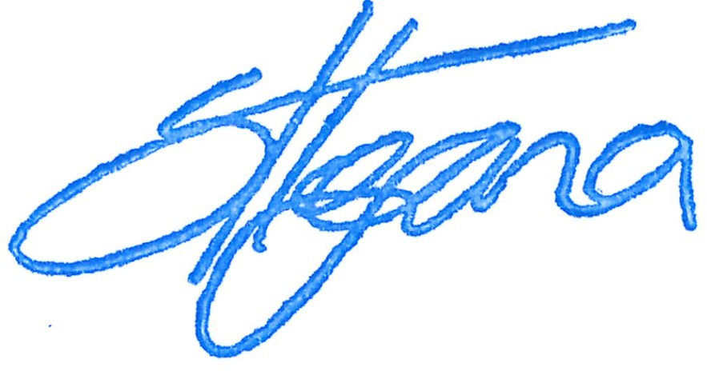

Shauna Hegna President

koniag.com Page 2 of 2